The PED Landscape

A topological map of Positive Energy District Topics, Projects and Results

Simon Schneider, DUT Expert Support Facility

# Abstract

Positive Energy Districts (PEDs) embody a transformative concept for sustainable urban development, integrating energy planning at the district level to create neighborhoods that generate more energy than they consume. Despite their potential, the broad and adaptable nature of PEDs has led to varied interpretations and fragmented applications, influenced by local contexts, priorities, and constraints. This paper introduces the “PED Landscape,” a comprehensive topological map of visually represented keywords designed to navigate the diverse and complex realm of PED topics, projects, and outcomes.

Utilizing the PESTEL framework (Political, Economic, Social, Technological, Environmental, and Legal), the PED Landscape organizes PED activities into more than hundred distinct keywords, that are assigned to one of the frameworks topics and visually represented by a isometric tile depicting that activity or concept.

In this paper, the landscape is used to map the focus and content of existing PED projects and visualize areas of high activity as well as research gaps.

By providing an organized, visual framework, the PED Landscape aims to bring clarity and order to the multifaceted PED environment. This tool not only simplifies the exploration of existing PED initiatives but also highlights pathways for innovation and enhanced social and environmental impacts, supporting the continued advancement of sustainable urban development.

# Introduction: PED is a powerful, flexible and diverse concept

Positive Energy Districts (PEDs) represent a powerful and flexible paradigm for advancing sustainability and integrating energy planning into urban and district-level development. As a new vision for the built environment, PEDs promise to reshape how cities and communities generate, distribute, and consume energy, ideally creating districts that produce more energy than they consume. This vision has inspired urban planners, architects, and policy-makers alike to explore more efficient, self-sustaining neighborhoods.

Yet, the concept of PEDs is not without its complexities. Its broad appeal comes from a simple, compelling narrative: a district with "positive energy." However, this same simplicity can be problematic—what does "positive energy" truly mean? The ambiguity of the term has led to a range of interpretations, which can make the concept difficult to fully define or universally embrace. This lack of a unified definition means that PEDs have been molded into different shapes, depending on local contexts, priorities, and constraints. The result is a rich but fragmented landscape of interpretations, each addressing unique challenges and opportunities.

PEDs have been employed to tackle a variety of issues across diverse countries, cities, and climates—from addressing energy poverty in disadvantaged areas to fostering community energy initiatives, and from urban high-rise neighborhoods to rural settings. The diverse application of PEDs reveals both their strengths and their complexities, highlighting the need for new methods and tools to better visualize and navigate the intricacies of these initiatives.

This paper introduces the concept of the "PED Landscape"—a topological map that represents the key topics within PEDs, organized according to the PESTEL framework (Political, Economic, Social, Technological, Environmental, and Legal). Each sphere is represented by a distinct color, and every tile within the map, designed by a graphic designer, captures a specific aspect of PEDs. This approach aims to offer a new way to understand, visualize, and engage with the diverse and evolving narrative of Positive Energy Districts, ultimately facilitating better planning, collaboration, and decision-making.

# Problem and Goal: Get some order in the PED jungle

As PED projects become increasingly numerous, so too do the initiatives undertaken under programs like DUT (Driving Urban Transitions). This rapid proliferation has led to a complex and sometimes overwhelming landscape, where similar approaches, ideas, and projects overlap without a clear structure. The PED Database represents one such effort to consolidate information, but it remains only part of the solution to understanding the broader PED context.

The goal of this paper is to create a topological map of all topics related to PED research and implementation projects—a "PED Landscape" that offers a comprehensive overview of the interconnected elements within this field. Beyond merely cataloging these topics, the aim is to provide a visual representation that is:

* **Attractive and Inviting**: Encouraging exploration and engagement with the diverse aspects of PEDs.
* **Cohesive**: Offering a unified view that makes connections between various topics and approaches clear.
* **Flexible and Extendable**: Allowing for the integration of new topics and developments as the PED concept continues to evolve.

The PED Landscape uses the PESTEL framework to structure and clarify the diverse range of topics. Each dimension of the PESTEL framework—Political, Economic, Social, Technological, Environmental, and Legal—offers a unique perspective that is crucial for understanding the full scope of PED initiatives. By organizing the landscape in this way, we can highlight the different drivers, challenges, and opportunities inherent to PED projects.

The visual design of the PED Landscape is intended to play a significant role in making the complexity of PED topics more accessible. Graphic design is used not only to enhance aesthetics but also to improve user experience by providing a clear, engaging, and easy-to-navigate map. The thoughtful use of color, layout, and visual cues makes complex information approachable, helping users—from researchers to policymakers—to better grasp the intricate connections within the PED ecosystem.

This tool is envisioned to be valuable for different stakeholders, such as urban planners, community leaders, policymakers, and researchers. For example, an urban planner could use the PED Landscape to identify best practices from similar climates or demographic contexts, while policymakers might find it useful for visualizing the regulatory and social impacts of PEDs. By creating an organized and accessible framework, the PED Landscape has the potential to accelerate the adoption and successful implementation of PEDs in a variety of contexts.

Ultimately, the PED Landscape aims not just to bring order to the "PED jungle," but also to create pathways for broader social and environmental impacts. By providing a clear and flexible representation of the PED landscape, we hope to inspire new collaborations, spark innovative solutions, and support the ongoing evolution of Positive Energy Districts as an integral part of sustainable urban development.

# Method: Creating the PED Landscape

The creation of the PED Landscape involved several key steps designed to ensure a comprehensive, organized, and visually engaging representation of PED topics:

**Collection of Topics and Themes**: The first step involved gathering a wide range of topics and themes related to Positive Energy Districts. This collection process drew from existing PED projects, academic literature, and policy documents, ensuring that all relevant aspects of PED research and implementation were considered.

**Clustering with PESTEL+(SM) Analysis(**Marten van der Laan): To bring order to the diverse topics, clustering was conducted using the PESTEL framework. This process categorized each topic under one of the six PESTEL dimensions—Political, Economic, Social, Technological, Environmental, and Legal. This structured approach helped to clarify the roles and relationships between various elements within the PED context. During development, two additional topics emerged: “Spatial” and “Processes and Methods”. The Spatial topic was considered to be a major common denominator and connector between different topics, which is why it was located at the center of the other six topics. Processes and Methods was also a meta-topic but not in the cpenter of attention. It was therefore

**Reduction into Keywords**: To facilitate visualization, each cluster was reduced into a set of representative keywords. This reduction process distilled the essence of each topic, ensuring that the core concepts were captured while minimizing granularity and complexity. Keywords were chosen to be clear, concise, and reflective of the broader themes they represent.

**Visualization**: Finally, the clustered topics and their associated keywords were transformed into a visual representation. A graphic designer worked to create a topological map where each PESTEL dimension was depicted in a distinct sphere of color, with individual tiles representing specific topics. The goal was to make the PED Landscape not only informative but also visually appealing and easy to explore, encouraging engagement and deeper understanding of the PED ecosystem.

# Result

Ein Bild, das Text, Screenshot, Schrift, Diagramm enthält.

Figure 1 Topological map for PED project keywords

## Keywords

|  |  |  |  |  |  |  |  |
| --- | --- | --- | --- | --- | --- | --- | --- |
| **Political** | **Economic** | **Social** | **Technological** | **Environmental** | **Legal** | **Spatial** | **Process and Methods** |
| City Missions | Market | **Community Engagement** | Local Renewable Production | Circularity | Multi-level Legislation | **Urban planning tools/instruments** | Co-Creation |
| Decision Support Tools | Financial Strategies | **Narrative& Storytellung** | Balanced Demand & Supply | Climate adaptation/Climate neutral | Urban Landuse | **District/neighbourhoods typologies** | Simulation |
| Political Engagement | Circular Economy | **Everyday Consumption & Production Practices** | Energy Savings | Energy efficiency | District Regulation | **Mobility** | Monitoring |
| Power Analysis | Cost Analysis | **Wellbeing & quality of life** | Conversion & Storage | Embodied energy | Participative Instruments | **PED boundaries** | Modeling Tools |
| Governance Structure | Affordability | **Behavioural Change & Awareness** | **Infstrastructure** | Green house gas emissions | Energy Communities | **Strategic planning** | Scalability |
| Distributive Implications | Support and Information | **Social Justice & Equity** | Multi-commodity energy systems | Landscape | Energy market structures | **Governance Framework** |  |
| Regulation and Subsidies | Ownership Structures | **Social Innovation** |  | Resource efficiency | Innovative Institutional Change | **Scalability** |  |
|  | Incentives | **Cultural context** |  | Resilience |  | **Infrastructure** |  |
|  | Business models | **Heritage** |  | Primary energy balance |  |  |  |
|  |  | **Policy** |  |  |  |  |  |

**Tileset**

**Ein Bild, das Zeichnung enthält.
**

Ein Bild, das Text, Zeichnung, Cartoon, Darstellung enthält.

**Usecase 1: Representing projects**

The first way to use the PED landscape is to visually represent a PED project by show of its designated keywords

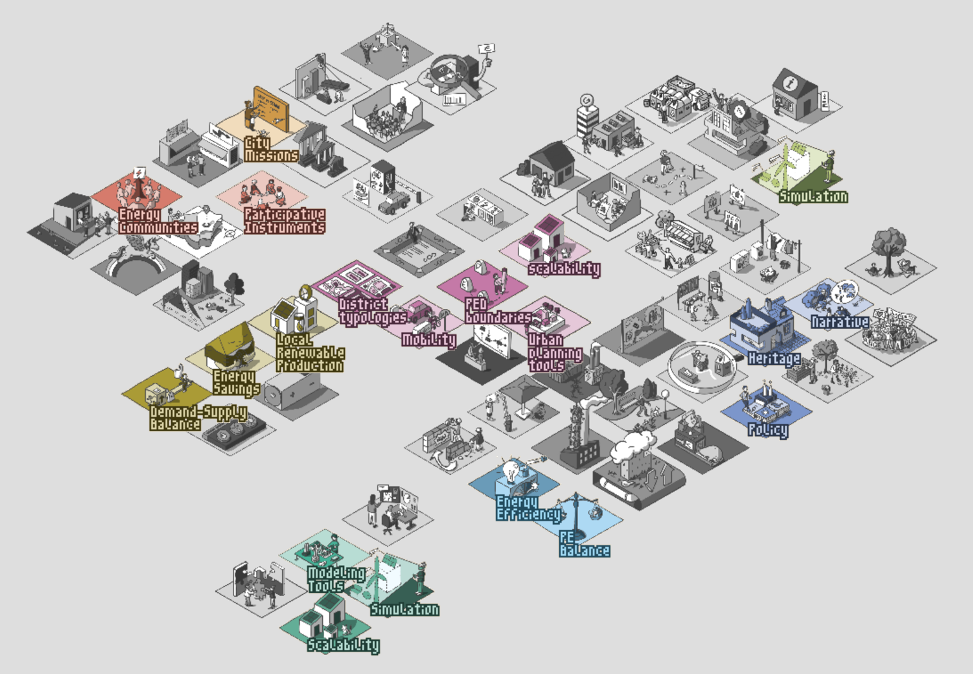

**Usecase 2: Mapping of results and deliverables**

# Discussion

## Use cases

Enza, can you add some other use cases or discussion?

## Limitations

# Appendix

|  |  |
| --- | --- |
| Economic | Topic |
| Market | Economic |
| Financial Strategies | Economic |
| Circular Economy | Economic |
| Cost Analysis | Economic |
| Affordability | Economic |
| Support and Information | Economic |
| Ownership Structures | Economic |
| Incentives | Economic |
| Business models | Economic |
| Urban planning tools/instruments | Spatial |
| District/neighbourhoods typologies | Spatial |
| Mobility | Spatial |
| PED boundaries | Spatial |
| Strategic planning | Spatial |
| Governance Framework | Spatial |
| City Missions | Political |
| Decision Support Tools | Political |
| Political Engagement | Political |
| Power Analysis | Political |
| Governance Structure | Political |
| Distributive Implications | Political |
| Regulation and Subsidies | Political |
| Local Renewable Production | Technological |
| Balanced Demand & Supply | Technological |
| Energy Savings | Technological |
| Conversion & Storage | Technological |
| Infstrastructure | Technological |
| Multi-commodity energy systems | Technological |
| Community Engagement | Social |
| Narrative& Storytellung | Social |
| Everyday Consumption & Production Practices | Social |
| Wellbeing & quality of life | Social |
| Behavioural Change & Awareness | Social |
| Social Justice & Equity | Social |
| Social Innovation | Social |
| Cultural ontext | Social |
| Heritage | Social |
| Circularity | Environmental |
| Climate adaptation/Climate neutral | Environmental |
| Energy efficiency | Environmental |
| Embodied energy | Environmental |
| Green house gas emissions | Environmental |
| Landscape | Environmental |
| Resource efficiency | Environmental |
| Primary energy balance | Environmental |
| Resilience | Environmental |
| Co-Creation | Process and Methods |
| Simulation | Process and Methods |
| Monitoring | Process and Methods |
| Modeling Tools | Process and Methods |
| Scalability | Process and Methods |
| Multi-level Legislation | Legal |
| Urban Landuse | Legal |
| District Regulation | Legal |
| Participative Instruments | Legal |
| Energy Communities | Legal |
| Energy market structures | Legal |
| Innovative Institutional Change | Legal |